

|  |  |
| --- | --- |
|  | **RV College of Engineering** |
| **Department of MCA**  **Modern Application Development workshop** |

|  |  |
| --- | --- |
| [Modern application development] | SAHANA R KORALLI |

**1 LOGIN PAGE**

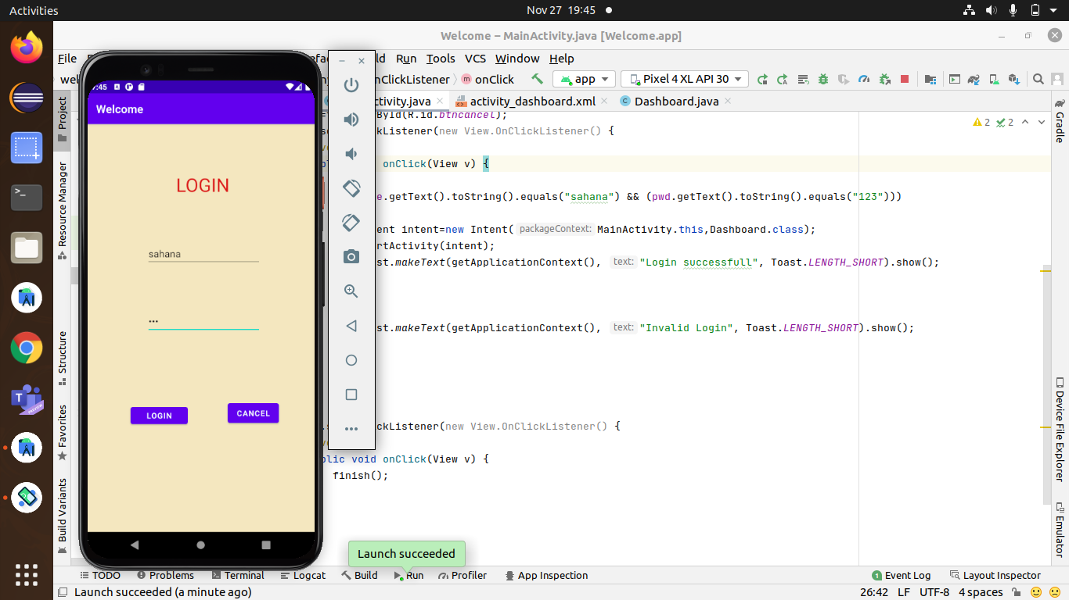

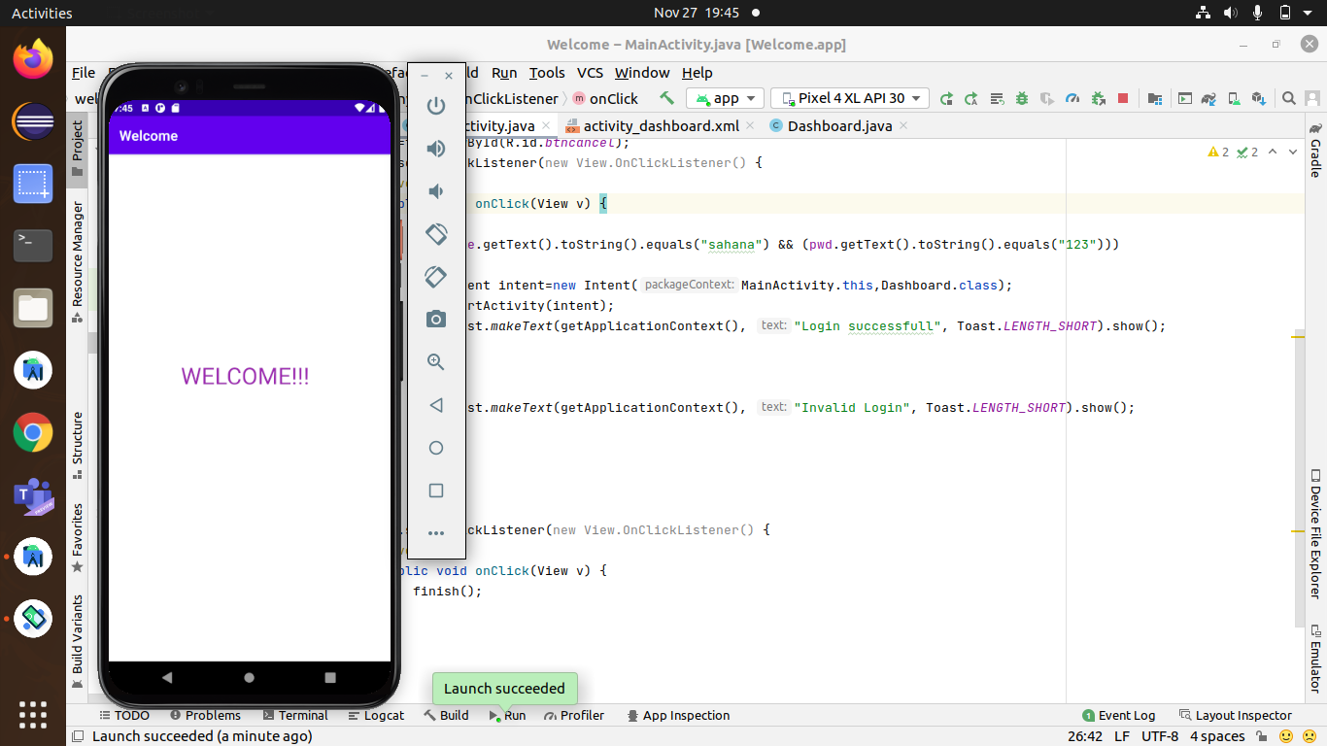

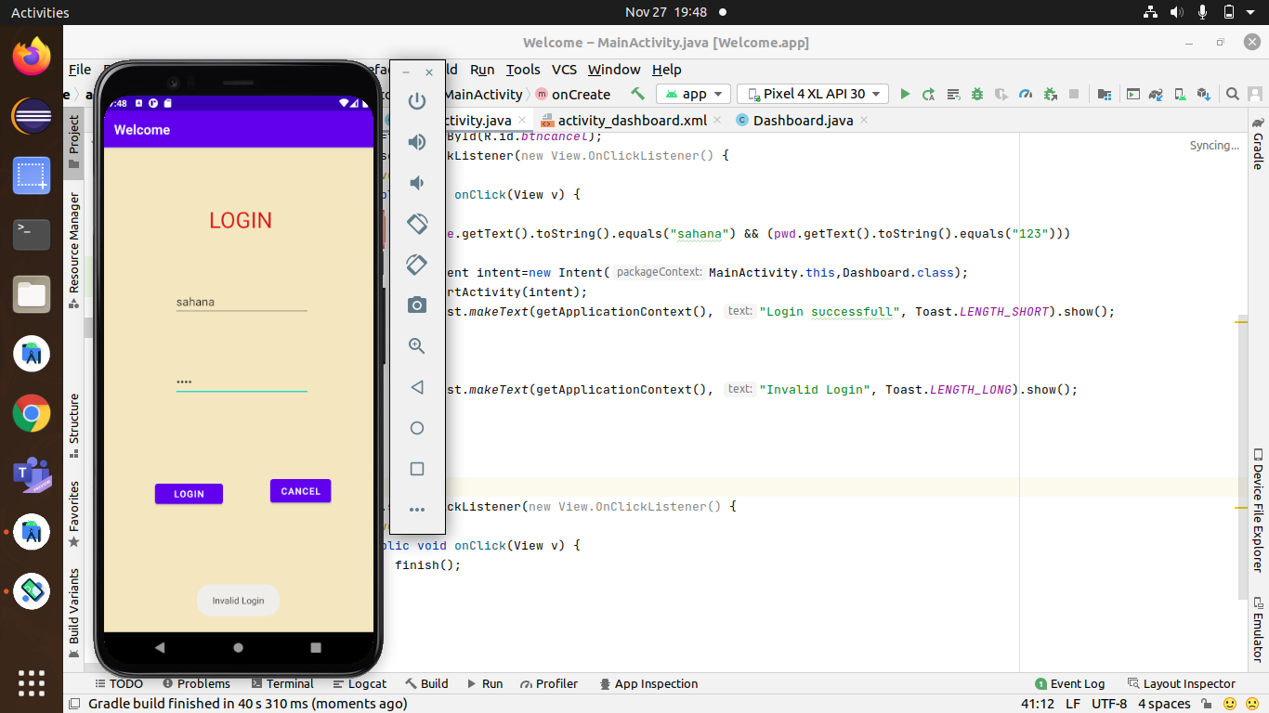

Learnt how intents are used with the help of simple login program.

Also learnt about the if condition statements.

**ANDROID ARCHITECTURE**

Android operating system is a stack of software components which is roughly divided into five sections and four main layers

Learnt about android architecture, the first file which gets created when opening a new project, purpose of gradle.

Got the idea of how the android work internally...

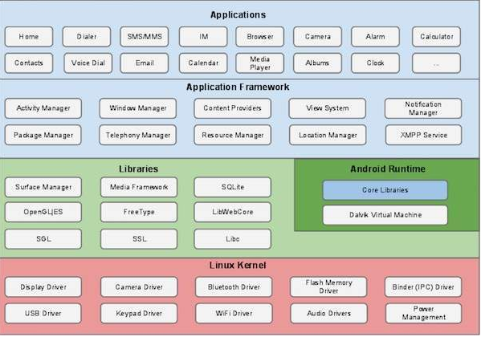

**SEEKBAR**

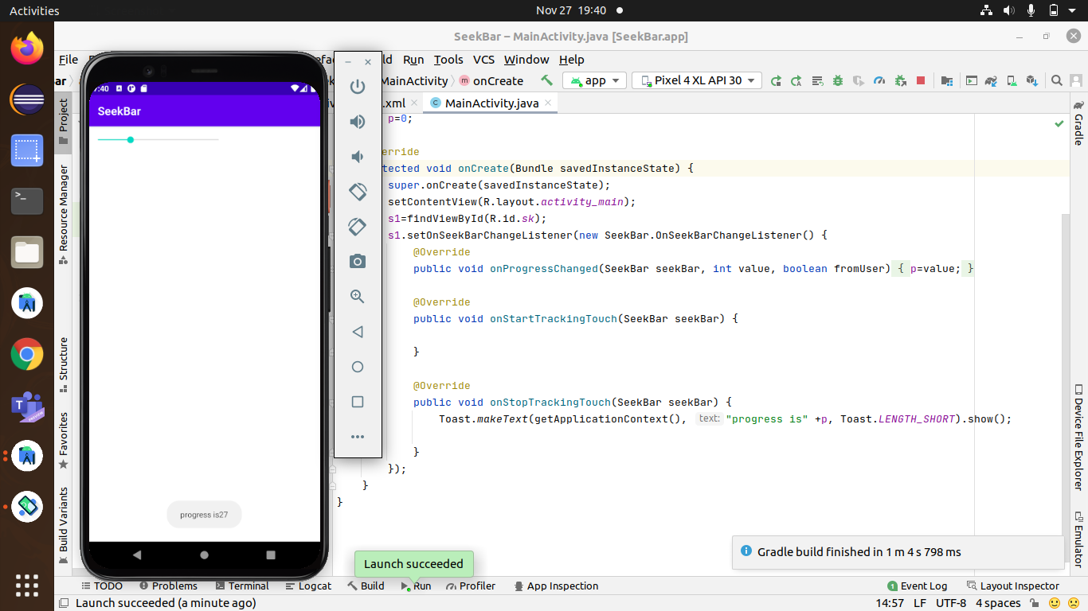

Learnt how to create a seek bar and set its max value

display its current value with a toast message.

We can set the initial and maximum values for seek bar through attributes also so that we can start with initial and maximum how it is moving. Also learnt about its uses such as to adjust volume, screen brightness etc.

by setting the max value in attributes and progress in java code

**3 Program to create menus**

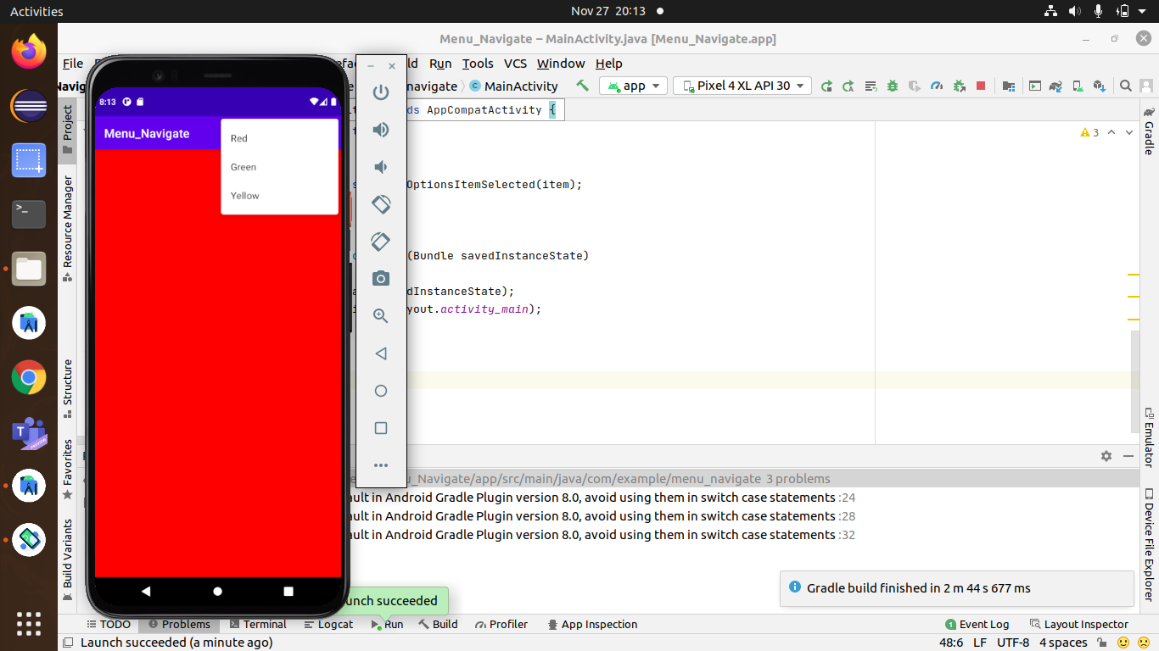

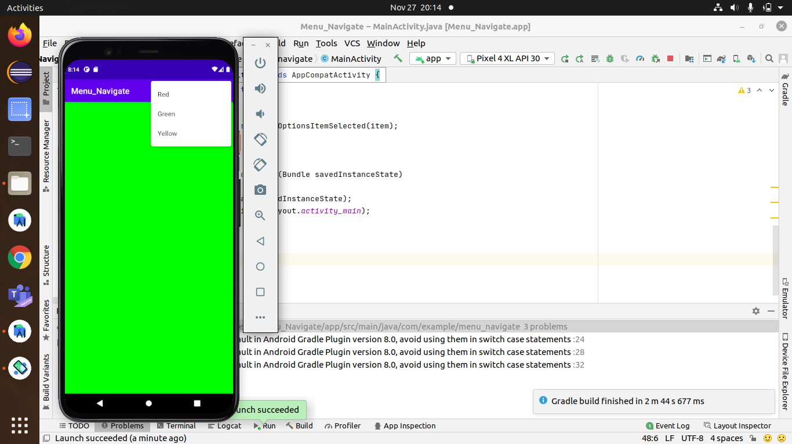

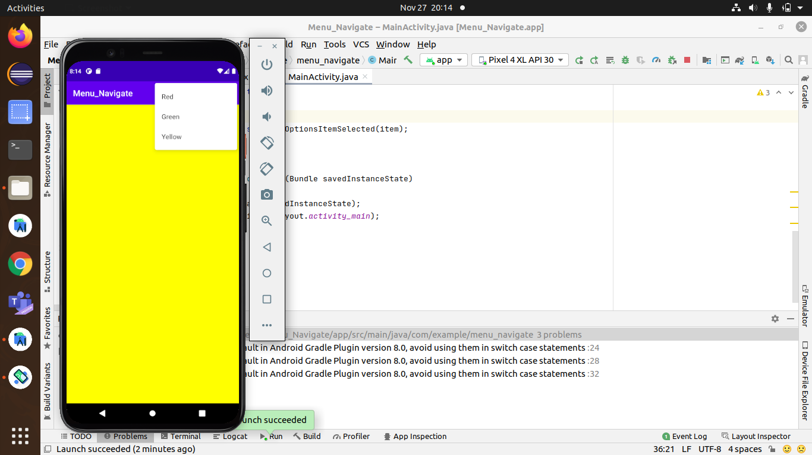

Learnt how to create android resource file to create menu items. Also learnt how to switch between the background colors.

**4 SPLASH SCREEN**

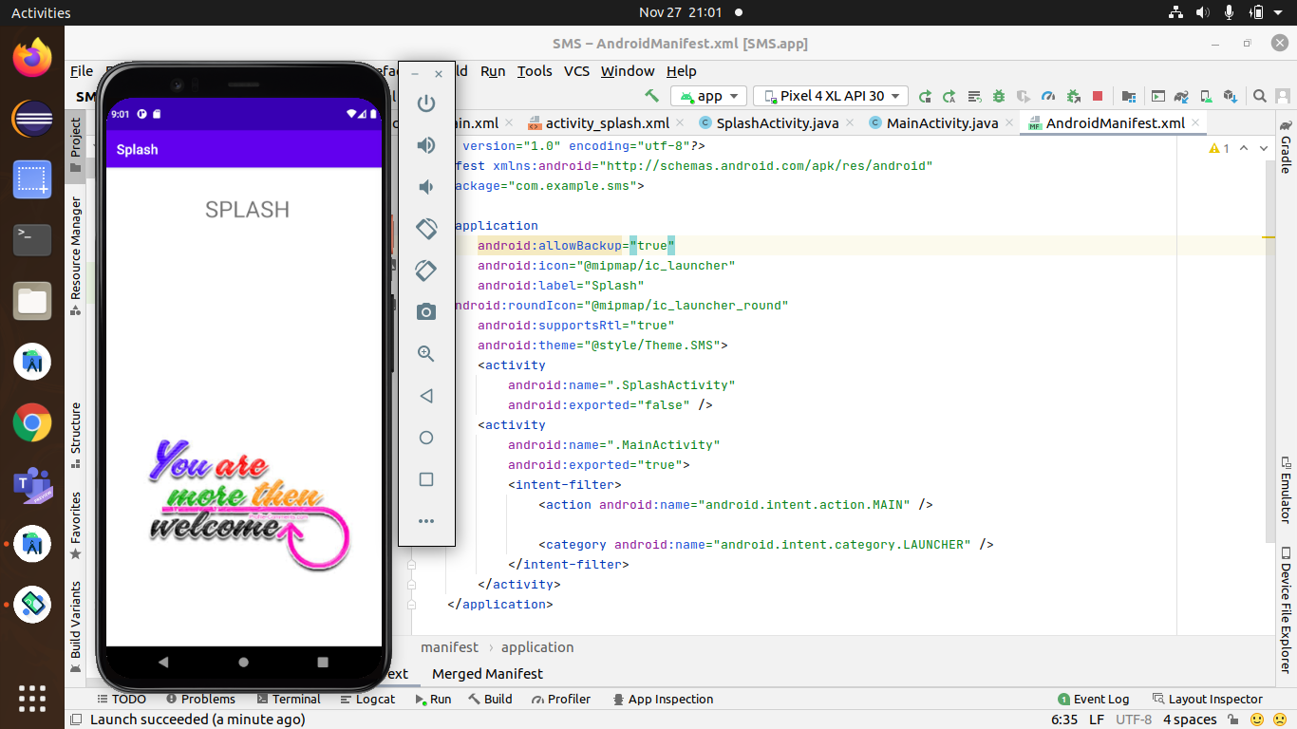

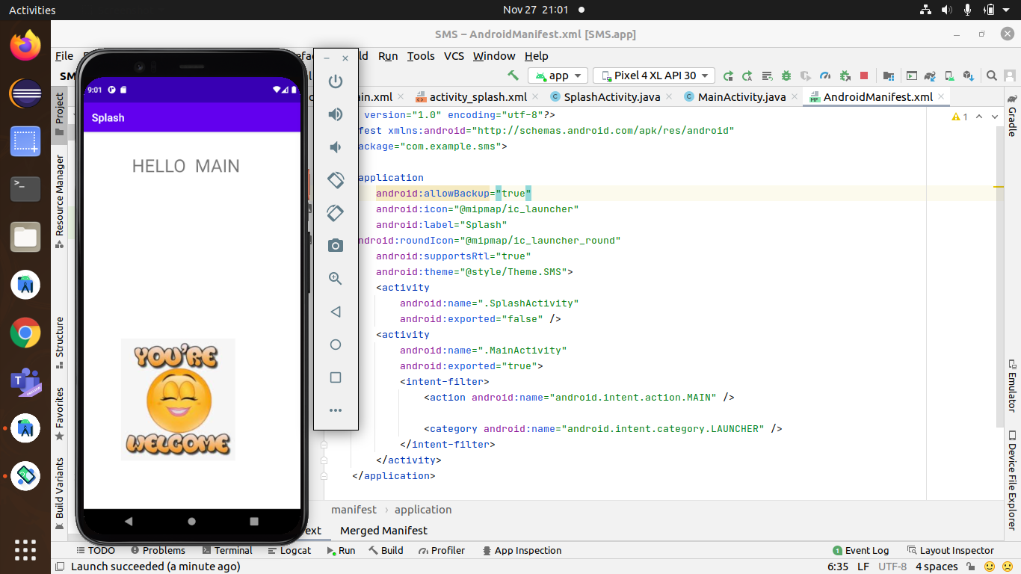

Most commonly the first startup screen which appears when App is opened. In other words, it is a simple constant screen for a fixed amount of time which is used to display the company logo, name, advertising content etc.

Learnt how to use the handler method and specify the time duration for the splash screen activity. In the manifest file we set the splash activity as the launcher activity. The activity uses external dependency to add a GIF component.

This is done by editing the manifest file

auto-navigate from one activity to another in the specified interval of time.

**5 DATETIMEPICKER**

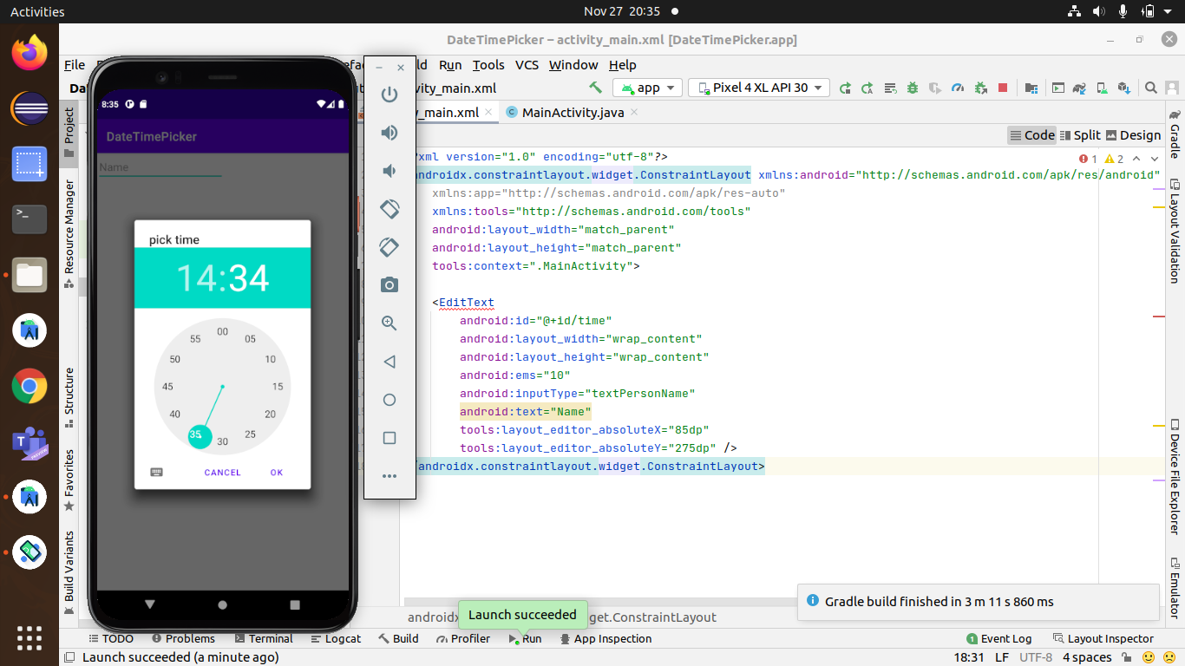

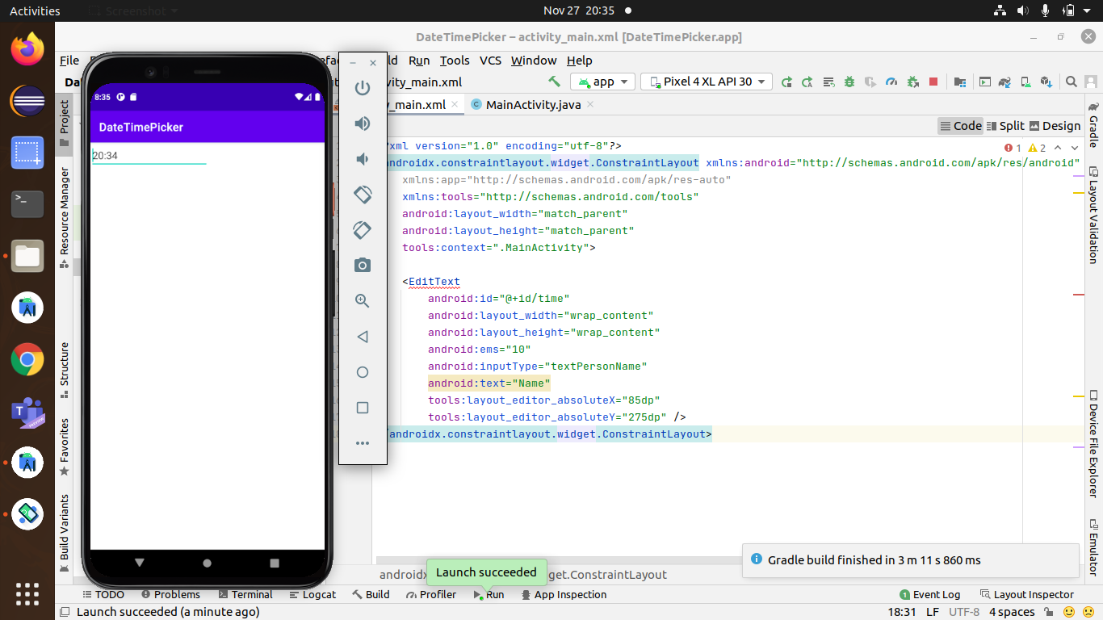

TimePicker is a widget used for selecting the time of the day in either AM/PM mode or 24 hours mode. The displayed time consist of hours, minutes and clock format. If we need to show this view as a Dialog then we have to use a TimePickerDialog class.

**6 RATING APP**

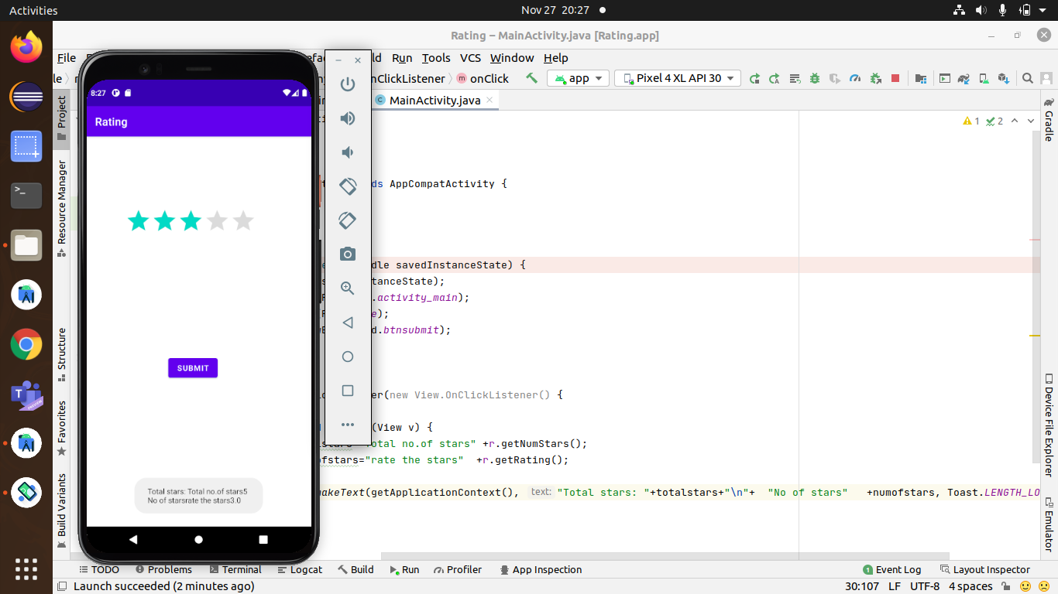

Android-Rate is a library to help you promote your android app by prompting users to rate the app

I learnt how i can incorporate in my project to take the feedback

7 SMS

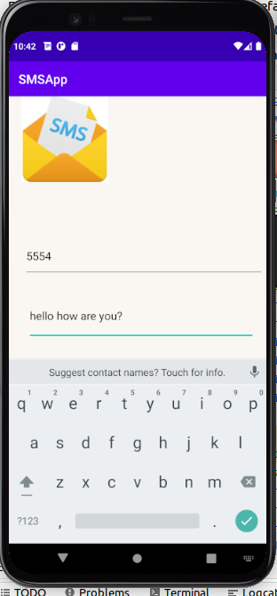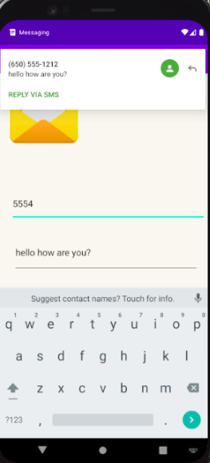

learnt about the Sms Manager and how to send across messages.

The app is used to send SMS to a given number. Although this requires an explicit permission to be set in the Manifest file, the app can only send SMS to the registered Emulator phones in the same device.

**8 SETTING APP ICON**

learnt how to set app icon

res folder-->right click-->image assets-->set the path of png file of app-->both foreground and background-->delete webp files from the launcher

learnt to set the color of icon

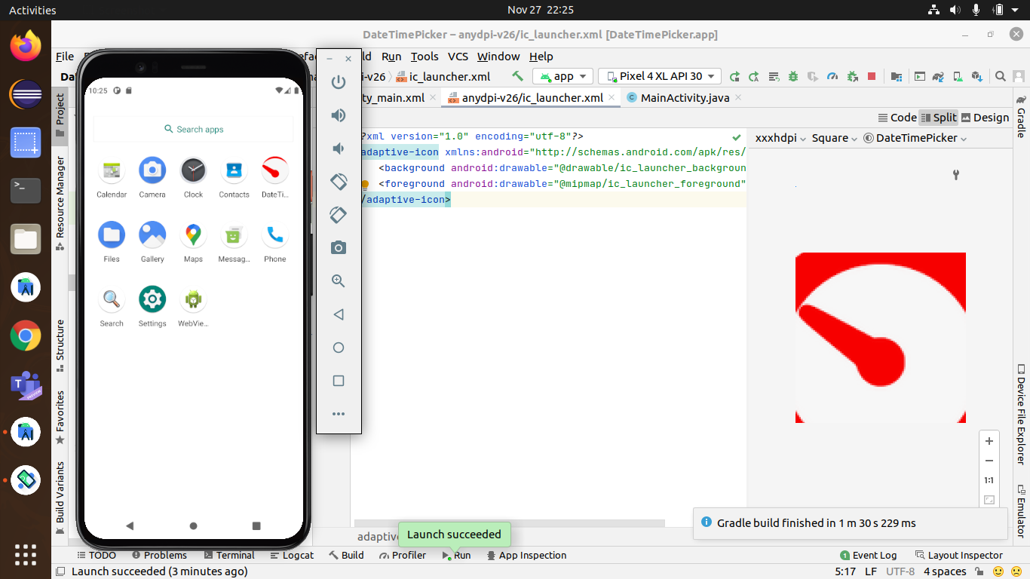

**9 BACK4APP**

learnt how back4app can be used to create login using back4app ,how to deploy the details of user in cloud